# Prezentarea solutiei

Exercitiul acesta are ca scop gestionarea unei baze de date pentru concerte. Printre functionalitatile incluse se numara filtrarea concertelor dupa buget si intervalul de timp, actualizarea statusului de "sold out" si suplimentarea biletelor la unele concerte.

# Dificultati intampinate

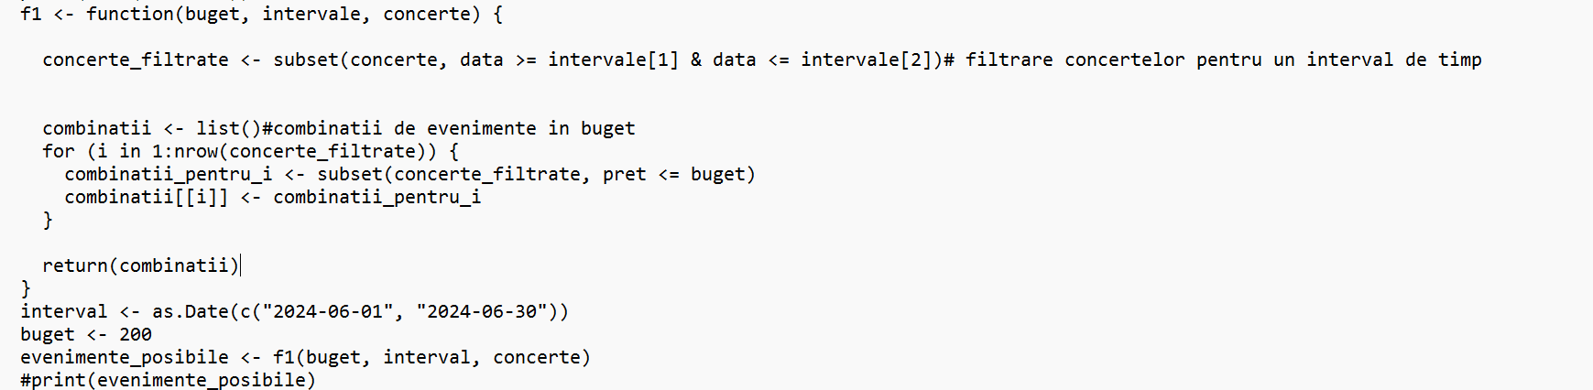

In cadrul functiei f1 de la punctul b), din cauza for-ului utilizat se repeta afisarea tabelului de 10 ori. Pentru a rezolva aceasta problema, am decis sa nu mai utilizam bucla for si sa aplicam filtrul pentru buget direct pe “concerte_filtrate” si returnarea rezultatului obtinut.

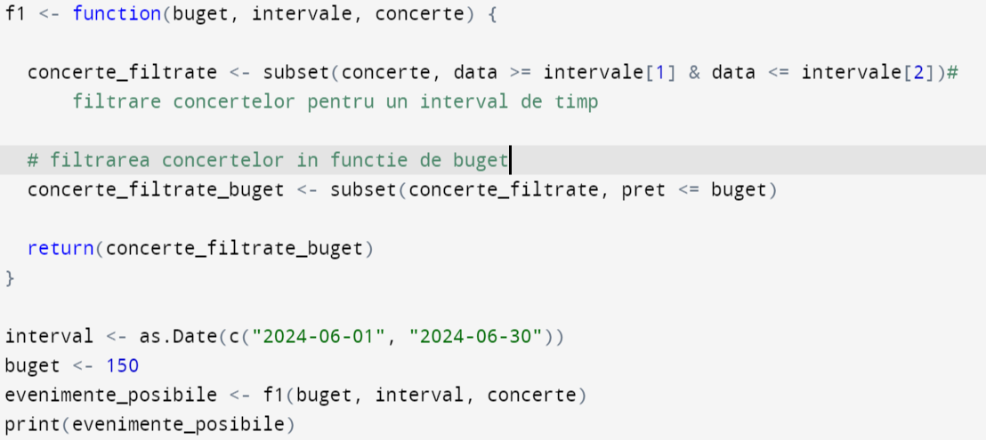

1. Datorita probabilitatii mici de 1% de a genera un concert soldout, a fost necesara hardcodarea unui concert ca fiind constant soldout (concertul cu id-ul 5), pentru a fluidiza testarea codului (subpunctele c, d si e).

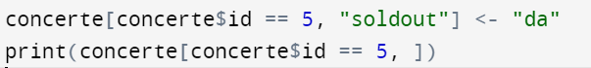

# Tabele

pret gen data oras soldout artisti

18 250.40741 pop 2024-06-26 Timisoara nu Artist4

32 99.59027 rock 2024-06-04 Timisoara nu Artist3

46 286.92500 pop 2024-06-21 Cluj-Napoca nu Artist1

51 178.62806 classical 2024-06-20 Iasi nu Artist2, Artist4, Artist1

54 285.06985 jazz 2024-06-23 Constanta nu Artist2, Artist1

57 144.23043 jazz 2024-06-18 Iasi nu Artist4, Artist2, Artist1

pret gen data oras soldout artisti id

5 187.4718 jazz 2024-09-17 Iasi da Artist1, Artist2 5

pret gen data oras soldout artisti id

1 281.96953 rock 2024-04-20 Iasi nu Artist2, Artist3, Artist5 1

2 166.55446 classical 2024-07-22 Bucuresti nu Artist1, Artist5, Artist2 2

3 66.46730 jazz 2024-05-15 Cluj-Napoca nu Artist1 3

4 177.21937 classical 2024-04-01 Iasi nu Artist3, Artist5 4

5 177.12458 hip-hop 2024-01-27 Cluj-Napoca nu Artist5, Artist3, Artist2 5

6 277.96322 classical 2024-08-25 Cluj-Napoca nu Artist5, Artist2, Artist4 6

7 107.19178 classical 2024-03-16 Bucuresti nu Artist5, Artist3, Artist1 7

8 255.36004 pop 2024-09-25 Iasi nu Artist4 8

9 245.08780 rock 2024-05-08 Iasi nu Artist3, Artist4, Artist5 9

10 257.15304 hip-hop 2024-09-08 Iasi nu Artist5, Artist3, Artist1 10

11 181.63270 jazz 2024-07-15 Bucuresti nu Artist2, Artist5, Artist4 11

12 296.14964 jazz 2024-10-22 Constanta nu Artist1 12

13 154.11035 classical 2024-03-05 Timisoara nu Artist5, Artist2, Artist3 13

14 212.80214 pop 2024-03-06 Iasi nu Artist5 14

15 75.62506 rock 2024-12-22 Iasi nu Artist4, Artist1 15

16 194.99102 pop 2024-08-08 Iasi nu Artist3, Artist5 16

17 287.54274 rock 2024-10-19 Timisoara nu Artist5, Artist2 17

18 158.53409 rock 2024-08-11 Timisoara nu Artist1 18

19 160.35135 pop 2024-04-28 Bucuresti nu Artist1, Artist5, Artist2 19

20 297.25244 pop 2024-08-05 Cluj-Napoca nu Artist4, Artist5 20

21 249.86392 jazz 2024-09-18 Constanta nu Artist2, Artist4, Artist3 21

22 120.61982 classical 2024-10-22 Cluj-Napoca nu Artist4 22

23 232.56391 hip-hop 2024-11-17 Iasi nu Artist2, Artist3 23

24 218.58422 pop 2024-07-15 Cluj-Napoca nu Artist3, Artist2 24

25 57.19852 rock 2024-05-16 Timisoara nu Artist2, Artist3, Artist4 25

26 273.31481 rock 2024-05-28 Cluj-Napoca nu Artist5 26

27 247.72201 hip-hop 2024-02-25 Bucuresti nu Artist2, Artist1 27

28 205.80115 hip-hop 2024-06-21 Cluj-Napoca nu Artist5, Artist2 28

29 260.22638 pop 2024-09-07 Bucuresti nu Artist5 29

30 206.78732 hip-hop 2024-05-29 Bucuresti nu Artist4, Artist1, Artist3 30

31 273.61476 hip-hop 2024-08-31 Constanta nu Artist5 31

32 153.06345 pop 2024-04-30 Iasi nu Artist5, Artist2, Artist4 32

33 71.12553 jazz 2024-01-27 Timisoara nu Artist3, Artist1 33

34 229.83592 hip-hop 2024-11-18 Timisoara nu Artist4, Artist3, Artist5 34

35 277.19302 pop 2024-05-03 Cluj-Napoca nu Artist1, Artist5 35

36 162.51259 hip-hop 2024-06-17 Constanta nu Artist5, Artist3, Artist4 36

37 258.18876 jazz 2024-11-10 Iasi nu Artist1, Artist5 37

38 209.61947 jazz 2024-07-17 Constanta nu Artist3 38

39 85.02312 jazz 2024-12-21 Constanta nu Artist1, Artist4, Artist3 39

40 151.13723 jazz 2024-11-08 Timisoara nu Artist2, Artist4 40

41 234.86732 rock 2024-04-16 Cluj-Napoca nu Artist5, Artist4 41

42 280.33846 classical 2024-02-12 Bucuresti nu Artist1 42

43 235.23538 hip-hop 2024-02-24 Constanta nu Artist1, Artist3 43

44 246.80181 hip-hop 2024-06-03 Bucuresti nu Artist5 44

45 263.14738 classical 2024-05-08 Cluj-Napoca nu Artist3, Artist4, Artist5 45

46 247.17214 hip-hop 2024-12-21 Timisoara nu Artist1, Artist5 46

47 194.91644 jazz 2024-01-17 Cluj-Napoca nu Artist3, Artist2, Artist4 47

48 259.39600 hip-hop 2024-09-19 Constanta nu Artist1 48

49 165.62648 classical 2024-01-19 Cluj-Napoca nu Artist3, Artist1 49

50 163.37808 pop 2024-03-15 Iasi nu Artist2, Artist1, Artist4 50

51 134.74188 rock 2024-07-04 Iasi nu Artist3, Artist2 51

52 189.53823 classical 2024-06-27 Bucuresti nu Artist4, Artist3 52

53 81.91106 rock 2024-02-03 Timisoara nu Artist1, Artist5, Artist3 53

54 250.54516 hip-hop 2024-07-21 Bucuresti nu Artist3, Artist5 54

55 166.89538 hip-hop 2024-02-04 Iasi nu Artist3, Artist5 55

56 177.77177 rock 2024-02-24 Bucuresti nu Artist1, Artist4, Artist2 56

57 205.47860 pop 2024-07-16 Constanta nu Artist2 57

58 70.42231 classical 2024-12-27 Constanta nu Artist5, Artist1 58

59 168.94995 pop 2024-09-13 Bucuresti nu Artist4, Artist5 59

60 220.83949 hip-hop 2024-09-02 Bucuresti nu Artist1, Artist4, Artist3 60

61 170.98853 classical 2024-02-22 Bucuresti nu Artist2 61

62 60.16166 hip-hop 2024-10-15 Bucuresti nu Artist3, Artist5 62

63 261.26637 classical 2024-07-17 Timisoara nu Artist3 63

64 79.29216 rock 2024-09-04 Cluj-Napoca nu Artist2, Artist3 64

65 95.66233 classical 2024-12-29 Bucuresti nu Artist5, Artist1 65

66 119.89351 rock 2024-03-22 Bucuresti nu Artist3 66

67 111.14798 pop 2024-11-10 Bucuresti nu Artist2, Artist5 67

68 63.95991 classical 2024-07-14 Bucuresti nu Artist5, Artist4, Artist3 68

69 204.60402 pop 2024-11-03 Iasi nu Artist1 69

70 126.50615 rock 2024-05-13 Timisoara nu Artist2, Artist3 70

71 236.09531 jazz 2024-05-22 Constanta nu Artist5 71

72 157.51913 rock 2024-06-29 Bucuresti nu Artist4, Artist1 72

73 239.40496 jazz 2024-07-07 Timisoara nu Artist4, Artist5, Artist3 73

74 217.19339 jazz 2024-07-20 Timisoara nu Artist3, Artist4 74

75 53.08084 jazz 2024-08-31 Timisoara nu Artist2, Artist1, Artist3 75

76 178.69603 jazz 2024-04-03 Bucuresti nu Artist4 76

77 286.25286 jazz 2024-08-15 Iasi nu Artist3, Artist1, Artist2 77

78 179.06238 hip-hop 2024-03-01 Cluj-Napoca nu Artist5, Artist3, Artist1 78

79 174.44653 hip-hop 2024-11-26 Iasi nu Artist2 79

80 56.25949 hip-hop 2024-01-07 Bucuresti nu Artist4, Artist1, Artist5 80

81 172.93607 rock 2024-08-02 Cluj-Napoca nu Artist3 81

82 196.03372 classical 2024-02-09 Cluj-Napoca nu Artist2, Artist5, Artist1 82

83 250.31160 pop 2024-01-22 Constanta nu Artist2, Artist5, Artist3 83

84 297.79822 pop 2024-07-14 Bucuresti nu Artist1 84

85 112.76945 classical 2024-06-20 Timisoara nu Artist3, Artist5 85

86 242.38725 rock 2024-01-25 Bucuresti nu Artist3, Artist1 86

87 203.06464 jazz 2024-09-24 Constanta nu Artist5, Artist3 87

88 126.26761 jazz 2024-01-11 Iasi nu Artist4, Artist3 88

90 210.47738 rock 2024-05-11 Constanta nu Artist1, Artist2 90

91 276.59040 hip-hop 2024-02-24 Iasi nu Artist3 91

92 298.52241 jazz 2024-05-20 Constanta nu Artist1, Artist2, Artist3 92

93 296.33229 hip-hop 2024-07-28 Constanta nu Artist2 93

94 205.78670 classical 2024-01-19 Bucuresti nu Artist1, Artist2 94

95 281.63563 jazz 2024-02-28 Timisoara nu Artist3, Artist1, Artist4 95

96 139.67344 hip-hop 2024-06-06 Bucuresti nu Artist1 96

97 186.73862 jazz 2024-10-05 Cluj-Napoca nu Artist2, Artist5 97

98 190.34525 hip-hop 2024-12-02 Timisoara nu Artist4, Artist2 98

99 67.38095 pop 2024-02-15 Timisoara nu Artist5, Artist2, Artist3 99

100 81.70632 pop 2024-03-26 Timisoara nu Artist3 100

# Codul sursa

# Subpunctul a)

n <- 100

concerte <- data.frame(

pret = runif(n, 50, 300), # Generare pret bilete în intervalul 50-300

gen = sample(c("rock", "pop", "jazz", "classical", "hip-hop"), n, replace = TRUE),

data = sample(seq.Date(as.Date("2024-01-01"), as.Date("2024-12-31"), by = "day"), n, replace = TRUE),

oras = sample(c("Bucuresti", "Cluj-Napoca", "Timisoara", "Iasi", "Constanta"), n, replace = TRUE),

soldout = rep("nu", n)

)

# Adaugare coloana cu artisti

concerte$artisti <- replicate(n, list(sample(c("Artist1", "Artist2", "Artist3", "Artist4", "Artist5"), sample(1:3, 1), replace = FALSE)))

# Subpunctul b)

# functie pentru filtrarea concertelor în functie de buget si interval de timp

f1 <- function(buget, intervale, concerte) {

concerte_filtrate <- subset(concerte, data >= intervale[1] & data <= intervale[2])# filtrare concertelor pentru un interval de timp

# filtrarea concertelor in functie de buget

concerte_filtrate_buget <- subset(concerte_filtrate, pret <= buget)

return(concerte_filtrate_buget)

}

interval <- as.Date(c("2024-06-01", "2024-06-30"))

buget <- 300

evenimente_posibile <- f1(buget, interval, concerte)

print(evenimente_posibile)

#Subpunctul c)

# Functie pentru actualizarea statusului de "sold out"

update_soldout <- function(concerte) {

probabilitate <- 0.01

for (i in 1:nrow(concerte)) {

if (concerte$soldout[i] == "nu" && runif(1) < probabilitate) {

concerte$soldout[i] <- "da"

}

}

return(concerte)

}

# Actualizare soldout si filtrare în functie de buget si interval

f1 <- function(buget, intervale, concerte) {

concerte <- update_soldout(concerte)

concerte_filtrate <- subset(concerte, data >= intervale[1] & data <= intervale[2] & soldout == "nu")

combinatii <- list()

for (i in 1:nrow(concerte_filtrate)) {

combinatii_pentru_i <- subset(concerte_filtrate, pret <= buget)

combinatii[[i]] <- combinatii_pentru_i

}

return(combinatii)

}

concerte <- update_soldout(concerte)

concerte$id <- 1:nrow(concerte) # Adaugare id unic pentru fiecare concert(solutia tehnica pentru a schimba informatia despre concertul respectiv fara a dezactiva restrictia de la c)

# Subpunctul d)

# Functie pentru suplimentarea biletelor

suplimentare_bilete <- function(concerte, id_concert) {

index <- which(concerte$id == id_concert)

if (length(index) == 1 && concerte$soldout[index] == "da") {

concerte$soldout[index] <- "nu"

}

return(concerte)

}

concerte[concerte$id == 5, "soldout"] <- "da"

print(concerte[concerte$id == 5, ])

# Suplimentare bilete pentru un concert specificat

concerte <- suplimentare_bilete(concerte, 5) # Se foloseste id-ul concertului

# Subpunctul e)

# Functie pentru filtrarea concertelor în functie de statusul soldout

filtrare_concerte <- function(concerte, soldout_status = NULL) {

if (!is.null(soldout_status)) {

concerte <- subset(concerte, soldout == soldout_status)

}

return(concerte)

}

concerte_disponibile <- filtrare_concerte(concerte, soldout_status = "nu")

print(concerte_disponibile)